Matematik, Niveau D
Opgave07-a: Arealberegninger
Navn: ____________________________________________ Hold: ________

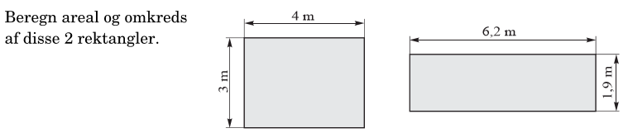
Opg. 1

A1: l * b = 4m * 3m = 12 m²
A2: l * b = 6,2m * 1, 9 m = 11, 78 m²
O1: 2* (l+b) = 2 * (4m+3m) = 14 m
O1: 2* (l+b) = 2 * (6, 2m+1,9m) = 16,2 m
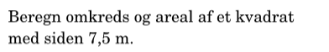
Opg. 2

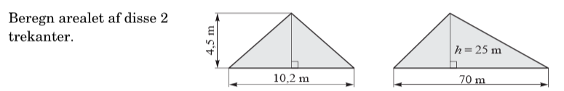
Opg. 3

Matematik, Niveau D
Opgave07-a: Arealberegninger (side 2)
Navn: ____________________________________________ Hold: ________
Opg. 4
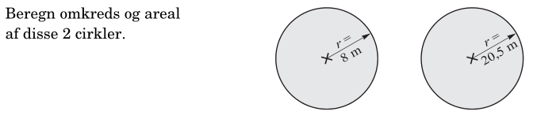

Opg. 5
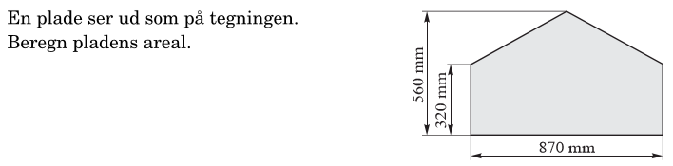

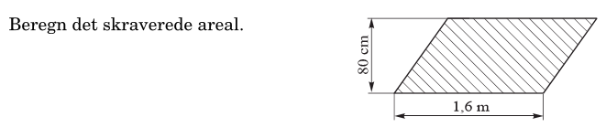
Opg. 6

Matematik, Niveau D
Opgave07-a: Arealberegninger (side 3)
Navn: ____________________________________________ Hold: ________

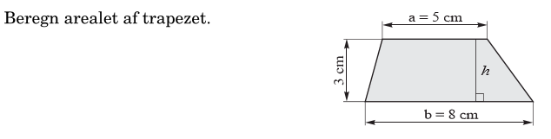
Opg. 7

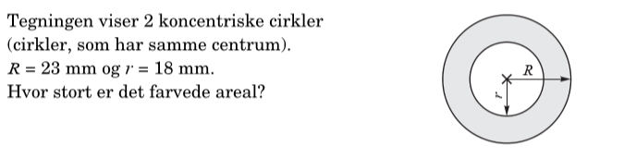
Opg. 8

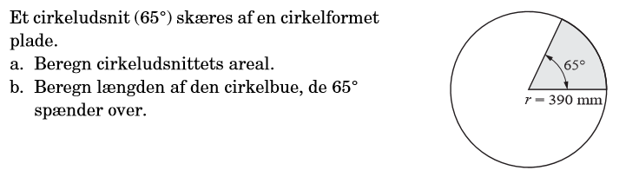
Opg. 9

